Experiment No. 1.8

Student Name: Parvinder Singh UID: 22MCC20043
Branch: MCA - CCD Section/Group: 22MCD-1/ Grp B
Semester: III
Subject Name: DevOps Process Automation Lab Subject Code: 22CAP-745

- Aim/Overview of the practical:
- Install and configure Puppet (Master and Slave).
- Generate, Send and Sign SSL certificate by Puppet Slave and Verify SSL Certificate on Puppet Master.

- Code for experiment/practical:

A. Install and configure Puppet (Master and Slave).
- Go to AWS and Create two Ec2 instances (I’m using Ubuntu 20.04) and Access both by Putty.
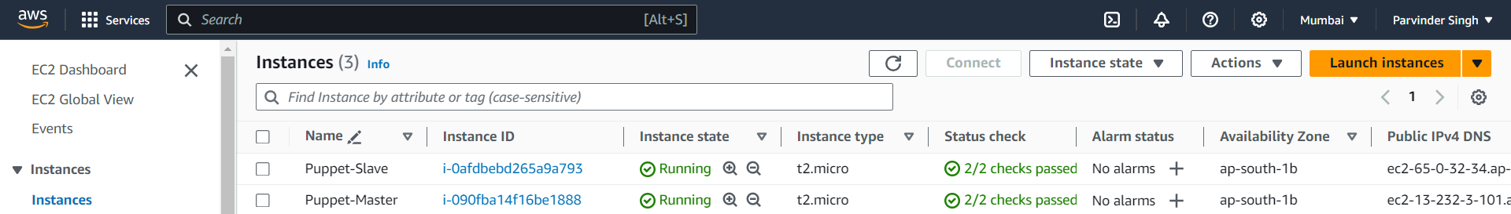
- Once both machines are accessed, First go to Puppet-Master and download the Puppet package. # wget https://apt.puppetlabs.com/puppet-release-bionic.deb
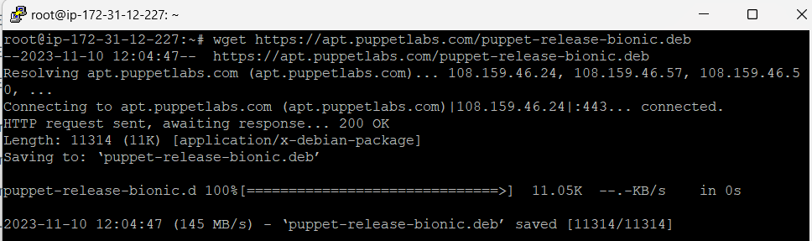
- Now unpack the package # sudo dpkg -I puppet-release-bionic.deb
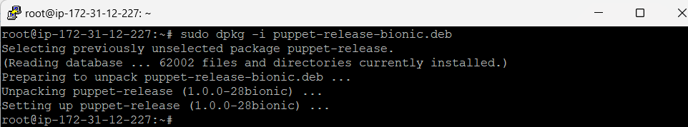
- Install the Puppet package # sudo apt-get install puppetmaster
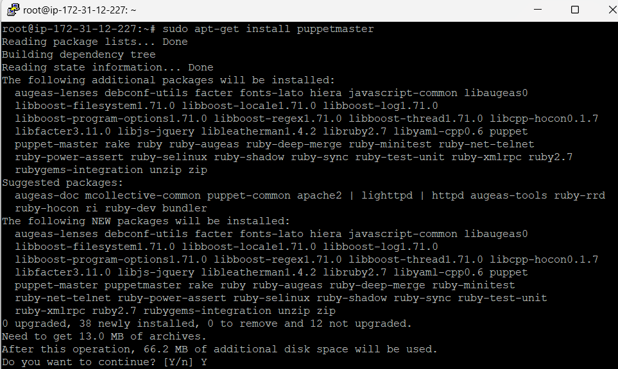
- Edit puppet master configuration file. # sudo vim /etc/default/puppet-master Add JAVA_ARGS=”-Xms512m -Xmx512m”
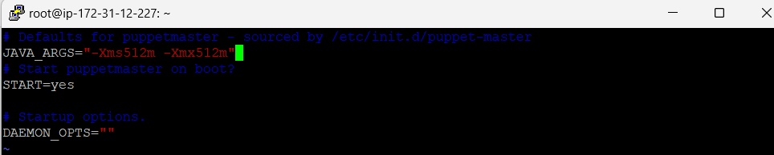
- Enable and start or restart the puppet-master services. # sudo systemctl restart puppet-master.service Also allow 8140/tcp connection
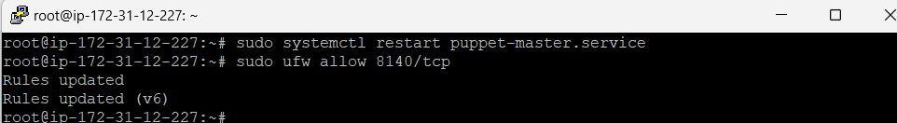

- Now go to Puppet-Slave machine and download the Puppet package. # wget https://apt.puppetlabs.com/puppet-release-bionic.deb
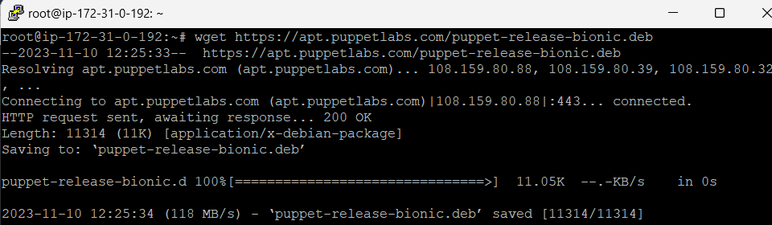
- Now Unpack the package and install puppet. # sudo apt-get install puppet
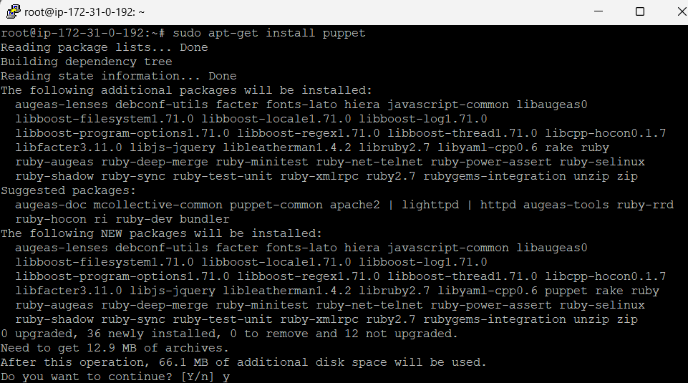
- Go to hosts file of Puppet-Master machine and config IP address of Puppet-Master machine.
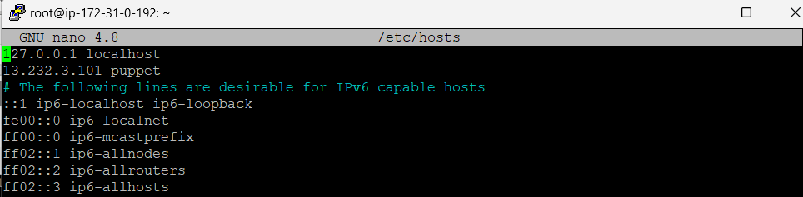
- Enable and start the puppet services # sudo systemctl start puppet # sudo systemctl enable puppet.
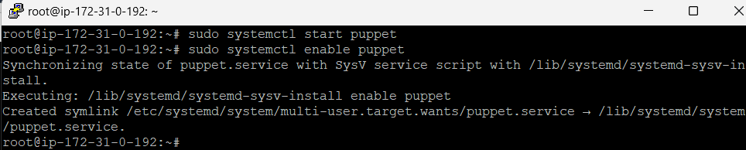
- Your Puppet-Master and Puppet-Slave machine are configured till now.

- Generate, Send and Sign SSL certificate by Puppet Slave and Verify SSL Certificate on Puppet Master.
- Once Puppet-Master and Puppet-Slave machine are configured and connected Puppet-Slave machine generate and send the SSL certificate to Puppet-Master certificate.
- Now go to Puppet-Master machine and list the SSL certificate. # sudo puppet cert list
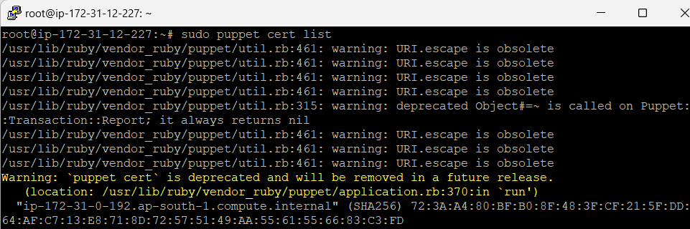
- Confirm the IP address by checking the SSL certificate request
- Now, Sign the SSL certificate request one by one manually or all (here I’m sign all certificate by –all flag). # sudo puppet cert sign –all
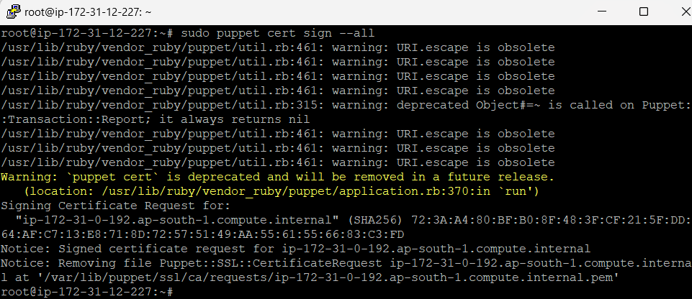

- SSL certificate signed successfully.

